Maintain Vacancy Types Knowledge Article

Contents
Document Version Control 1
Approved process for raising 2
Consultation & Approval 2
Change Management 2
How to 3
Testing 5
Communications 5
Downstream Systems & Processes 5
Affected Reports 5
Additional Background Information 5

Document Version Control
Change History/Review Details
Date | Version | Review by | Summary of Change
05/07/23 | 0.1 | Michael O’Sullivan | Initial Draft

Approved process for raising
Does the change need to be raised through a particular route or by a particular person/team? Are there any actions which need to be taken or considered prior to processing in the HRIS Support Centre?
The Standard process for creating or amending Vacancy Types is for the request to be made via an Incident that will be assigned to the Functional Analysis team within OSM the Oxford Service Management tool. It should be clear from the incident if the request is for a new Vacancy Type or an amendment to an existing.

Vacancy Types are linked heavily with the Recruitment process. Any proposed new or changes to existing Vacancy Types should be raised by the Head of Recruitment following the above route.

Consultation & Approval
Who is the owner of this information? Who needs to be consulted about this change before you begin work on it? Does anyone need to approve this change before it is implemented?
The Head of recruitment is primarily responsible to agree any new or changes to Vacancy Types.

The Functional Analysis team within HR Systems are responsible for maintaining the data within the PeopleXD system.

Change Management
What type of change is this? When should approval be sought and from whom (internal to team or change manager)? Who would normally be responsible for implementing?
New or changes to existing Vacancy Types should be raised as a Medium Change within OSM the Oxford Service Management tool. All requests will need to be tested in a UAT environment before entering into the live production environment.

How to
Technically how to process the change in the system
Adding a new ….
Navigate to: PeopleXD > People Management > Data Centre > Reference Data > Vacancy Types

Each reference data item is listed in order of the Vacancy Types Code. This is an alpha code which itemises each Vacancy Type and has a vague relationship with the Description, once set these cannot be changed but the “Description” of each can be.

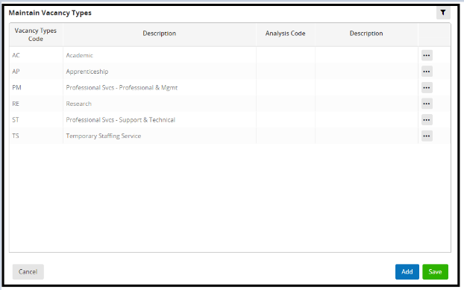

It is not possible to delete a Vacancy Types Code if being used on the Recruitment Maintenance Table, which occurs if the code has been used on a Vacancy record.

If possible, you should look to recycle existing codes as there is no option to set them as active or inactive. If new codes do need to be created, simply click on the Add button

The “Position Types code” can be any code not yet used. The “Description” column has a limit of 40 characters including spaces and will be the list which is shown on the jobs website search screen to end users so must be logical and descriptive. The “Description” will be provided by the Head of recruitment.
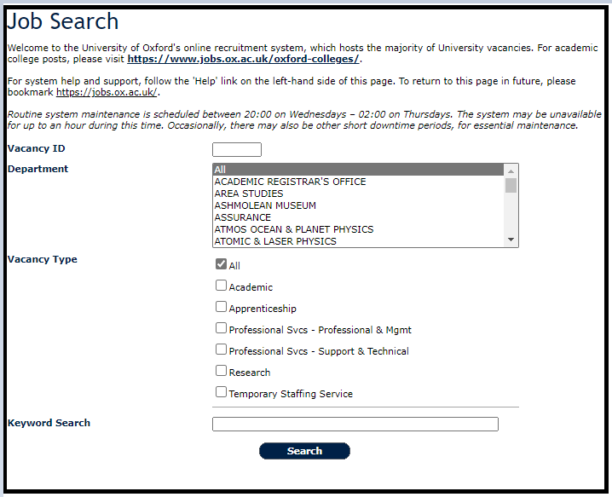

Changing a ….
Navigate to: PeopleXD > People Management > Data Centre > Reference Data > Vacancy Types

Each reference data item is listed in order of the Vacancy Types Code. This is an alpha code which itemises each Vacancy Type and has a vague relationship with the Description, once set these cannot be changed but the “Description” of each can be.

It is not possible to delete a Vacancy Types Code if being used on the Recruitment Maintenance Table, which occurs if the code has been used on a Vacancy record.

If possible, you should look to recycle existing codes as there is no option to set them as active or inactive. If new codes do need to be created, simply click on the Add button

The “Position Types code” can be any code not yet used. The “Description” column has a limit of 40 characters including spaces and will be the list which is shown on the jobs website search screen to end users so must be logical and descriptive. The “Description” will be provided by the Head of recruitment.

Removing a ….
Navigate to: PeopleXD > People Management > Data Centre > Reference Data > Vacancy Types

You cannot delete or mark these codes as inactivate once set up and selected within a Vacancy as this creates a link within the Recruitment Table.

If the code has not been utilised and there are no Recruitment Maintenance Table links then this can be deleted. Click on the Ellipses button and select Delete.

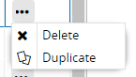

Where a code is no longer required but has been utilised and Recruitment Table links exist, you would need to consider migrating the existing data to another Vacancy Type before the ability to delete would be available.

Standard Icons & Terminology
Standard Button Names  Enter Query button:  Previous Record button:   Previous Section button:   Save button:   Insert Record button: 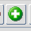 | Execute Query button: 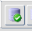  Next Record button:   Next Section button:  LOV button:   Delete Record button:  | Cancel Query button: 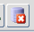  Red Door button:   Duplicate Record button:
Navigation Paths

Show the final navigation path option in bold+italics, for example;
Core|Personnel > Reference > Reference A – C > Accident Codes
Core|Pay > Reference > Pay Groups

Any further navigation beyond the navigation path can be added after an ellipsis (…), for example;
Event Management > Event Configuration … HR Events > Change of Address

Testing
Who would normally be responsible for testing? Are there standard items to test?
Functional testing can be carried out by using the new/amended codes on a vacancy and the jobs website.

User Acceptance Testing should also always be carried out to ensure that any changes made to these codes fit the central recruitment processes.

Communications
Who needs to be informed (but not consulted) about this change? Detail when they should be informed (before or after the change).
The Business Change team within HR Systems along with input from the Head of Recruitment should manage the bulk of the communications as any amendments to this list will indicate a change of Recruitment process.

Downstream Systems & Processes
Details of any processes which are affected or need to be carried out following, or as part of, the change. Please detail any triggers, actions required and when the actions should be carried out.
QRGs may need to be updated.

Affected Reports
Are there any standard reports which may need to be updated following this change?
Review any reports that include the specific reference data or data type.

Additional Background Information
Any other relevant information, links to supporting documentation etc.

